Auto Ticket Classification using Flow Designer
Part 5 of 7 — Flow Designer Automation (Milestone 3)Part 5 of 7 — Flow Designer Automation (Milestone 3)

Milestone 3: Automation using Flow Designer & Email Notification
When a student creates a new IT support ticket, they only need to enter the Caller Name and Short Description of the issue. The student does not need to manually select the Category or Subcategory. Once the ticket is submitted, a Flow Designer automation is triggered and evaluates the Short Description for predefined keywords such as WiFi, Projector, Password, or Slow. Based on the identified keyword, the flow automatically assigns the appropriate Category and Subcategory to the ticket.
- If the short description contains the word WiFi, the flow assigns Category = Network and Subcategory = WiFi.
- If the description contains Projector, the flow assigns Category = Hardware and Subcategory = Projector.
- If the description includes Password or Login, the flow assigns Category = Access and Subcategory = Forgot Password.
- If the description mentions Slow or Hanging, the flow assigns Category = Performance and Subcategory = Slow Computer.
This automation ensures consistent classification, eliminates human error, and significantly reduces the manual effort required by IT staff. The entire process is implemented using Flow Designer, making the solution easy to maintain, scalable, and completely no-code.

Activity 1: Auto Classification using Flow Design
- Go to All menus → Search Flow designer.
- Under Process Automation, open the Flow designer.
- On the top right corner, click New and select the Flow option.
- Name: Auto Classify School IT Tickets.
- Application: Global.
- Now click the Build Flow button.
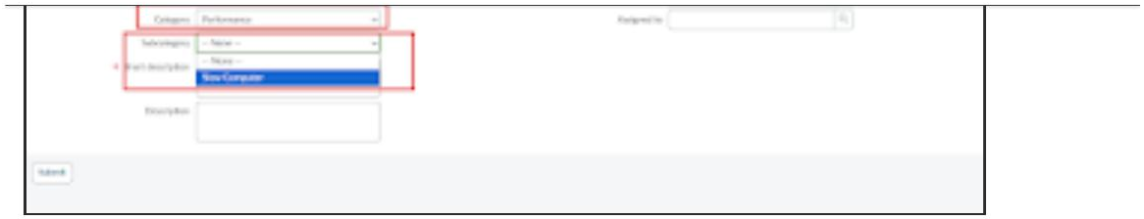
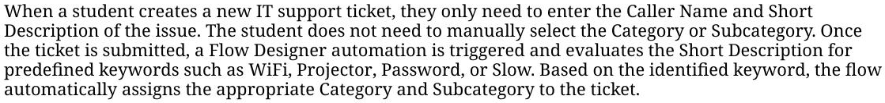
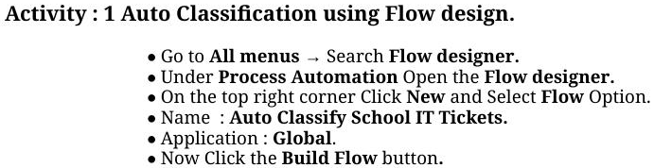

Activity 2: Trigger Configuration
- Trigger: Record Created.
- Table: Incident Workflow.
- Condition: Category is Empty.
- Then click Done.
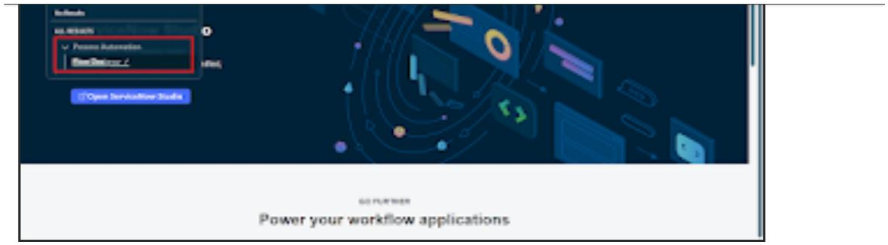
- Now under Actions, select the Flow Logic option.

Activity 3: Wi-Fi Issue Classification
- Select the If condition.
- Condition label: SD is Wifi or Network (name it as preferred).
- Condition 1: using the data pill picker, select Short description as Field, operator Contains, value Wi-Fi.
- Condition 2: Short description Contains Network.
- Then click Done.
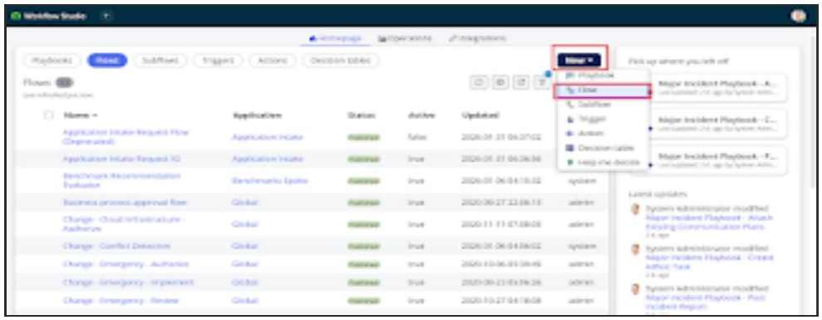
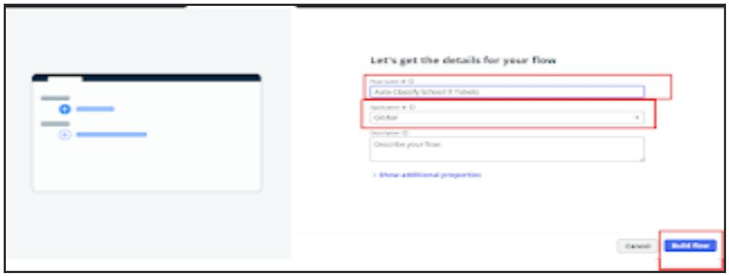
- Now click Action → Update record.
- Table auto-updates as Incident Workflow.
- Set Category = Network, Subcategory = Wi-Fi.
- Then click Done.
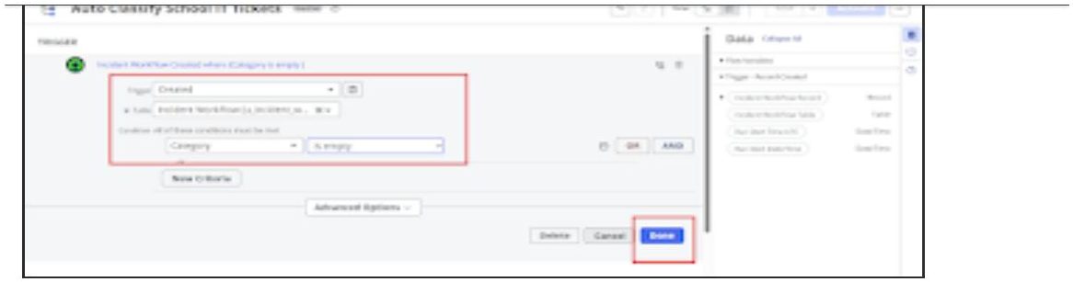

Activity 4: Projector Issue Classification
- Select the Else If condition.
- Condition label: SD is Projector or Hardware.
- Condition: Short description Contains Projector.
- Action: Update record — set Category = Hardware, Subcategory = Projector.
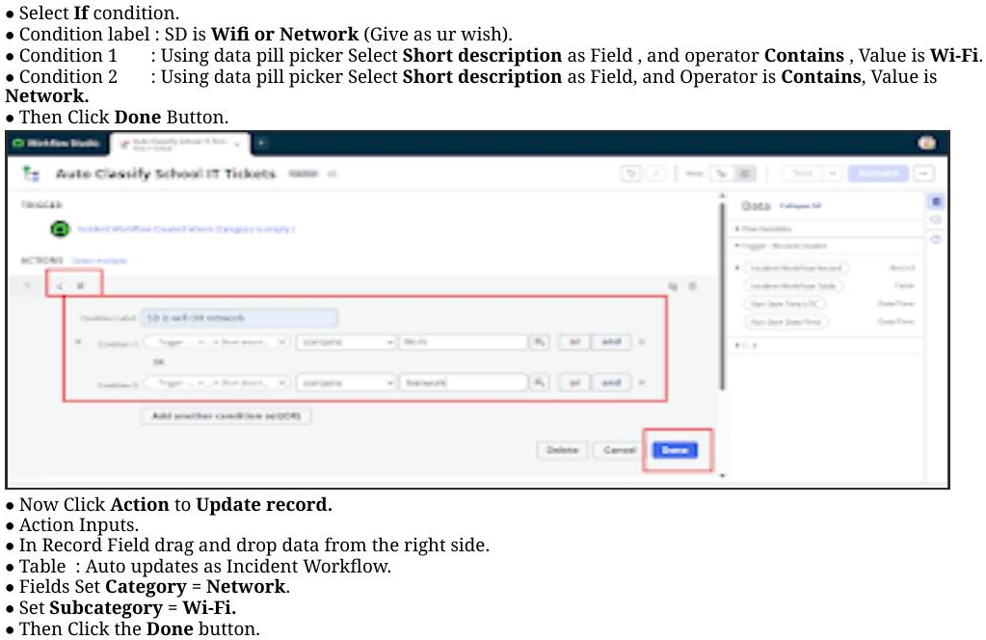
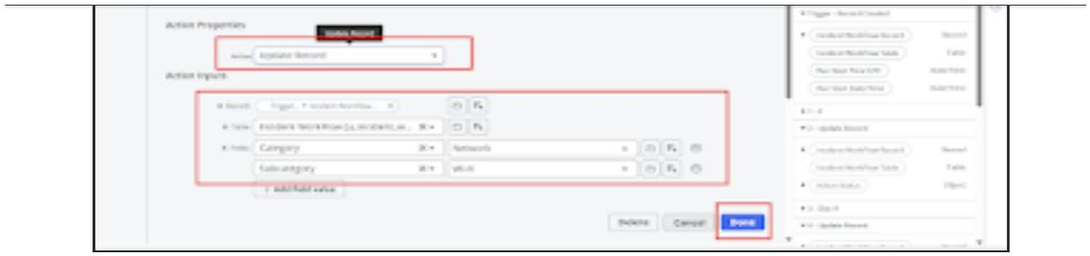

Activity 5: Password Issue Classification
- Select Else If condition.
- Condition label: SD is Forgot password.
- Condition: Short description contains Forgot password.
- Action: Update Record — set Category = Access, Subcategory = Forgot Password.
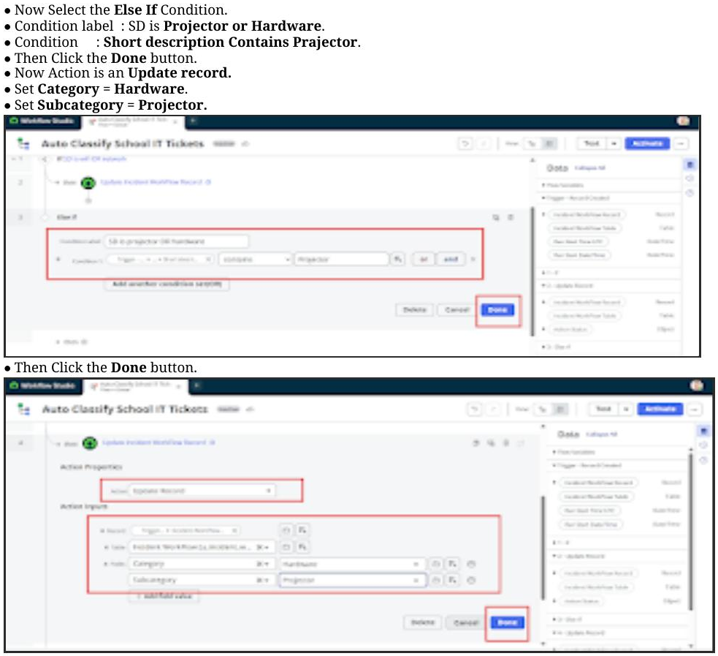
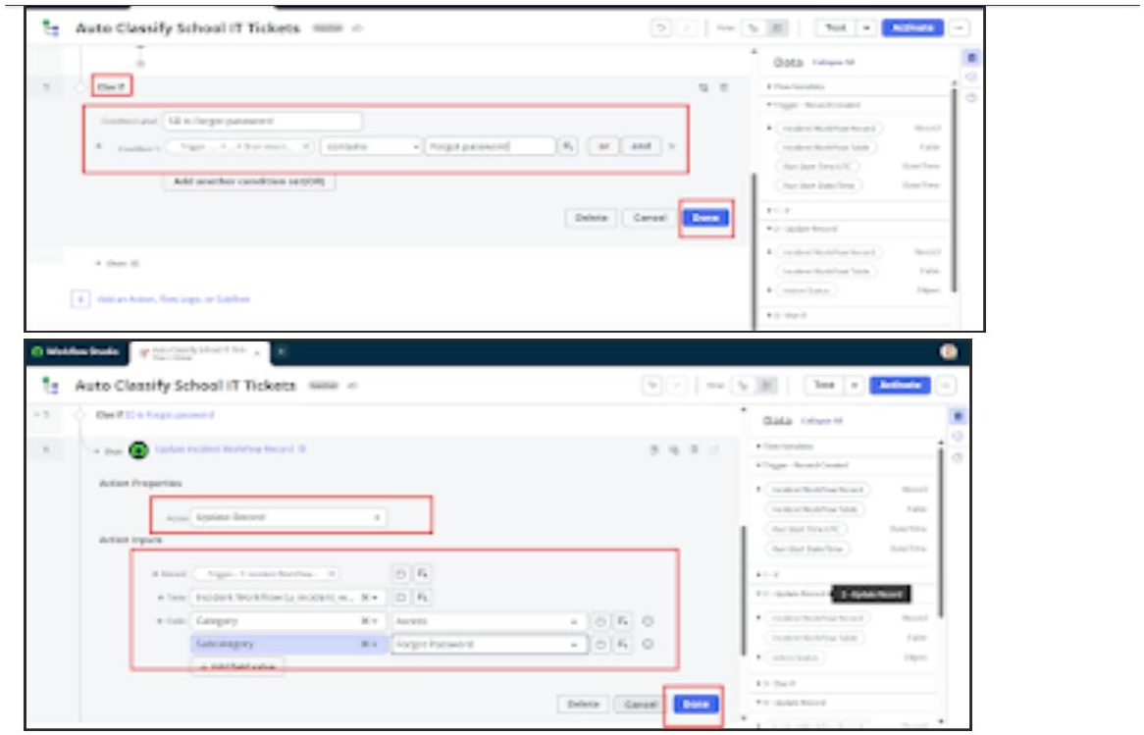

Activity 6: Slow Computer Classification
- Select Else If condition.
- Condition label: SD is Performance.
- Condition: Short description contains Slow Computer.
- Action: Update Record — set Category = Performance, Subcategory = Slow computer.
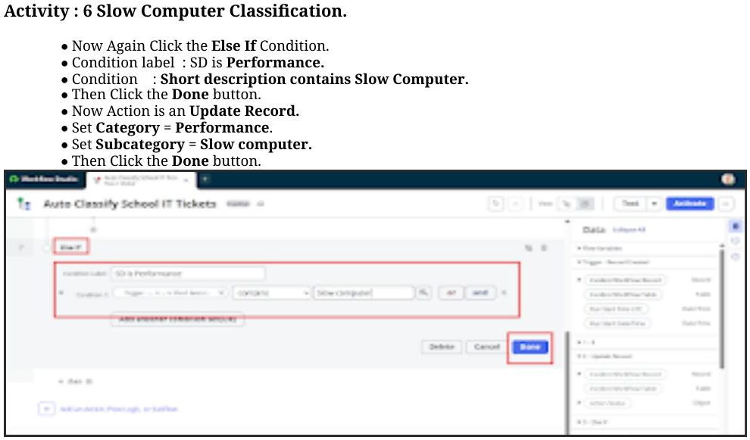
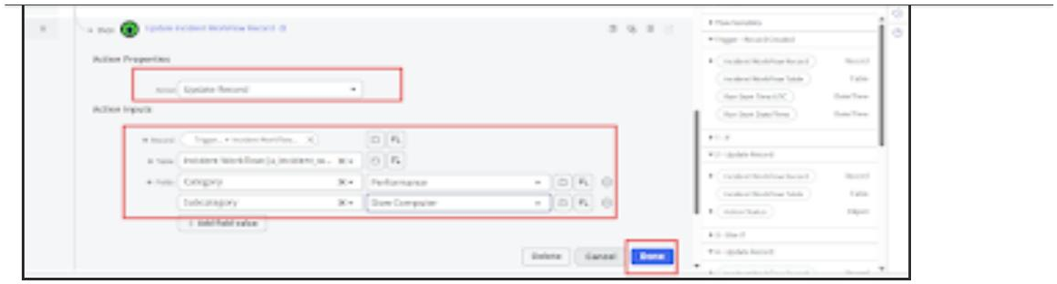

Activity 7: Email Action Setup
- After classification, an email notification is sent using Flow Designer.
- Set Action: Send Email.
- To: Caller → Email.
- Subject: Your Request for the issue has been submitted.
- Body: Ticket confirmation message.
- Then click Done, and click Activate from the top right corner.
